2026 Gender Pay Gap Employer Statement

Introduction
Office of Parliamentary Counsel (OPC) participates in the Workplace Gender Equality Agency (WGEA) public sector reporting program. This program helps identify gender equality issues and put action plans in place.
This Gender Pay Gap Employer Statement was endorsed by the First Parliamentary Counsel, Meredith Leigh (she/her) on 9 February 2026.
The Statement provides OPC’s commitment to providing a gender equal experience at work, and to address gender pay gap disparities.

Our current workforce gender profile
In December 2024, OPC’s workforce was disproportionally female, with 64% of employees overall being female. While all of our most senior positions are occupied by women, Figure 1 below demonstrates that there is close to gender parity in the upper pay quartiles. However, a gender imbalance is clear in the lower pay quartiles, which are predominantly female.
Our pattern of employing predominantly women in lower paid, administrative positions reflects current community norms. Our long-standing pattern of employing an equal number of women in higher paid, senior professional positions is one of which we are proud.
Figure 2 below shows that the number of women employed at OPC has been greater than the number of men employed for over 10 years, including the number of women in Senior Executive Service positions. While the data is not directly comparable (Figure 1 reports pay quartiles and Figure 2 reports classifications), the patterns are similar.
Our employment patterns at lower classifications are similar to the APS as a whole. APS-wide data show that women have historically been underrepresented at higher classification levels (EL 2 and above) and overrepresented at lower classification levels (APS 2–6).

Figure 1: Gender composition by pay quartile December 2024
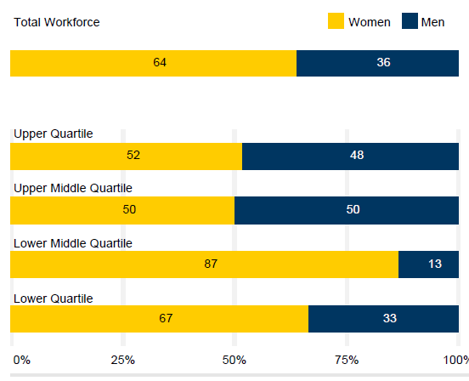
Figure 2: Historical gender composition by classification June 2012

Our current gender pay gap
Our gender pay gap is reported as the median of total remuneration and base salary, shown in Figure 3 below. At 22.5% and 22.0% respectively, both of these median figures show that the gender pay gap is improving relative to 2023. Analysis of the data reveals that the primary driver of our gender pay gap is the low number of men employed in the lower pay quartiles, as noted above.
This does not mean that women are paid less than men for the same role. Equal pay, the legal requirement to pay people the same amount for doing the same job, or a job of similar value, has been the law for over 50 years.
Figure 3: OPC gender pay gap as reported by the Workplace Gender Equality Agency
 | 2024 | 2023
Average total remuneration | 9.7% | 15.4%
Median total remuneration | 22.5% | 29.3%
Average base salary | 4.8% | 13.7%
Median base salary | 22.0% | 28.8%

Why does it matter?
Research has shown that a diverse, inclusive workforce is more productive and innovative. Such an organisation is better at attracting and retaining the best workers, no matter what their backgrounds are. Having a diverse workforce builds trust with our stakeholders, as we will reflect the community we serve.

Our diversity and inclusion strategy
The aim of our Diversity and Inclusion Strategy is simple: to make OPC a place where our people feel respected and valued, our workplaces are safe, our workforce is diverse and our culture is inclusive.
We are working to achieve equity, which is about creating a fair environment that addresses power imbalances. It means enabling everyone to access what they need to be successful. This can vary depending on the disadvantage and systemic barriers which some people experience compared to others.
We are working to achieve inclusion, which is enabling genuine participation and contribution, where everyone, regardless of their background, identity or circumstances feels valued, accepted and supported to thrive at work.

Our current practices and goals
The Workplace Gender Equality Act 2012 requires employers with 100 or more employees to report annually against six Gender Equality Indicators (GEI), of which OPC has achieved strong results already against 5 of the 6 indicators.
We have yet to achieve GEI 3 – equal remuneration between women and men, which refers to the gender pay gap. Since our last Employer Statement was published in early 2025, we have:
- Reviewed our processes for entering into individual enhanced remuneration ensure there is equality of opportunity (a level playing field) for all genders.
- Increased our promotion of parental leave for men, and published data internally on parental leave usage.
Further actions we are taking to reduce our gender pay gap are:
- Reviewing the language and location of advertising for APS 4-6 positions to better attract male candidates.
- Including our commitment to gender equality and inclusion in induction and recruitment materials, including roles and expectations of all employees.
In addition, we will:
- Enhance our training for supervisors to support employees experiencing family and domestic violence.
- Drive change beyond our workplace by promoting gender equality in our suppliers.

Conclusion
We will continue to strive to achieve a more equal balance between women and men, as well as ensuring an inclusive work place for our non-binary colleagues. We do this because we believe that it results in a more productive and sustainable workplace.

https://www.apsc.gov.au/remuneration-reports/australian-public-service-remuneration-report-2021

