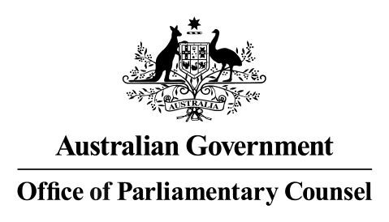
First Parliamentary Counsel
Office of Parliamentary Counsel Privacy Impact Assessment Register
All OPC Privacy Impact Assessments required under the Australian Government Agencies Privacy Code will be listed in this register, which is updated twice each year.
Reference No. | Date Posted | Title
Nil

Meredith Leigh
First Parliamentary Counsel
24 February 2026
________________________________________________________________________________________________________________
28 Sydney Avenue Forrest ACT 2603
Locked Bag 30 Kingston ACT 2604 • Telephone (02) 6120 1405 • Fax (02) 6120 1402 • ABN 41 425 630 817 fpc@opc.gov.au • www.opc.gov.au

