What is a table of contents?
The table of contents (TOC) is a list of headings within a document that typically appears before the body of the text.
While a TOC is not mandatory for legislation published on the Register, using correctly styled headings within a Word document allows you to insert a TOC using ordinary Word features that will automatically update. Correctly styled headings can also provide consistency, accessibility and assist search engines to read the document.
As of December 2025, the Register supports documents that include a hyperlinked TOC in the Word document when published to the Register. When a Word document includes a hyperlinked TOC, the TOC will remain in the Word document as well as generate a table of contents (bookmark) in the PDF version to assist with navigation. For the ePub version, the TOC will display on the left-hand side navigation pane on the Register. Please note: the page numbers will not display in the ePub version for a hyperlinked TOC. A static or manually created TOC will continue to appear with page numbers in the ePub version.

Creating a table of contents
- In the Word document, place your cursor where you would like the table of contents.
- Navigate to References in the ribbon at the top of the document. Select Table of Contents and select the style of TOC that is suitable for your document.
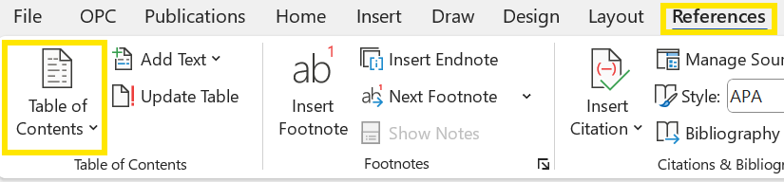
- If you make edits to your document after inserting a TOC, you will need to update the TOC to see the changes reflected. Update your table of contents by right-clicking on the shaded TOC. Select Update field>Update entire table.
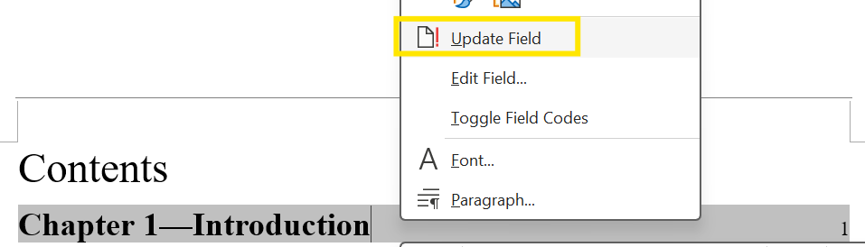
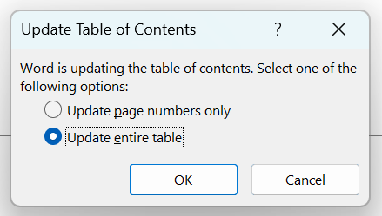
- The automated TOC in Word is created using the heading styles applied throughout the document. We recommend using Draft view in Word to easily review the styles applied to your document and identify headings with inconsistent formatting that may affect the TOC.
- For best results, consistently apply formatting and styles to all headings. This practice ensures that the TOC reflects the intended structure and prevents unexpected changes occurring during conversion. Additionally, updating styles to have consistent formatting prior to lodging reduces the likelihood of TOC issues and improves navigability for users of the Register.

Lodging
- When you have attached a document in the lodgement form, please check the PDF and ePub versions. In addition to the regular review, you should check the TOC appears and works as expected. If there are issues with the TOC, you can investigate the below solutions.

Common issues and solutions
Issue 1: Unexpected text is appearing in the TOC (e.g. a sentence rather than the section heading).
Solution: The heading style may have been applied to the paragraph text as well. Updating the paragraph text to the appropriate style may resolve this. If an edit is made to the text, make sure to update the TOC afterwards by following steps 3 and 4 above.

Issue 2: A section heading is missing from the TOC.
Solution: This may be missing if the relevant heading style has not been applied. Alternatively, it may be that the TOC fields were not updated after previous updates.

Issue 3: The page numbers are incorrect or are misaligned.
Solution: This can occur when certain edits or section breaks are introduced to the document. Check the page numbering and section breaks are correct throughout the document, then update the TOC.

Additional resources
Microsoft Support provides detailed guides on a variety of Word functions and services. These guides walk through how to create and update TOCs in Word.
Insert a table of contents - Microsoft Support
Update a table of contents - Microsoft Support
Customize or create new styles - Microsoft Support
The Australian Government Style Manual provides further information on headings and the best practice use of styles in Government writing. It also provides suggestions for consistency and accessibility across documents.
Headings | Style Manual

Contact us
If you have any questions or require additional support with lodging, please email lodge@legislation.gov.au or call the Register helpdesk on (02) 6120 1350.

